Economics Data-response Question

China-US Trade War

Personal, Social and Humanities Education Section
Curriculum Development Institute
Education Bureau
2020

(This DRQ is designed by Dr. Lee Shu Kam, Director of Business, Economic and Public Policy Research Centre, Hong Kong Shue Yan University in a project commissioned by the EDB)

The China-US Trade War

Source A: The origin of the trade war between the US and China
The trade war originated when the US President Donald Trump signed a memorandum on March 22, 2018, required the US trade representative to impose tariffs on imported goods from China. He accused China of unfair trade practices that caused imbalanced trade pattern which is shown in the figure below between the two countries. He also claimed that many jobs in the US were stolen by China.

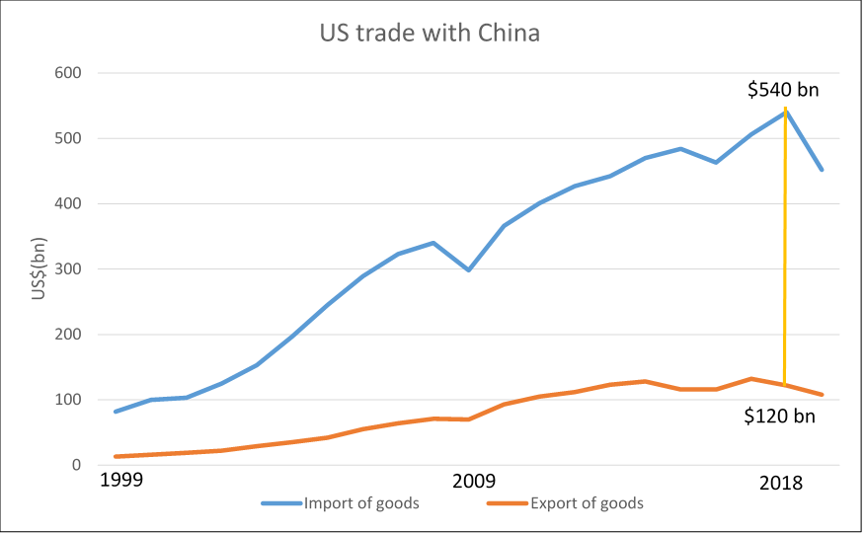

On July 6, 2018, the United States imposed an additional 25% tariff on Chinese exports worth US$ 34 billion. The Ministry of Commerce of the People’s Republic of China made countermeasures on the same day and imposed a 25% additional tariff on the US exports worth US$ 34 billion, including soybean from the US.

Source: collated news from the internet, 2019 & Office of the United States Trade Representative
website (https://ustr.gov/countries-regions/china-mongolia-taiwan/peoples-republic-china )

Source B: The exchange rate between USD and RMB (2018- 2019)

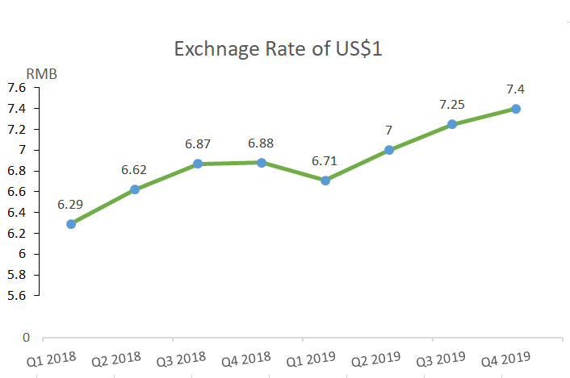

Source C: Views of a group of economists about the impacts of trade war on the US

US President Donald Trump claimed that the tariff on China’s import can bring the jobs and manufacturing back to the US. However, the economic figures in US do not agree to his claim.
In the US, many businesses find it harder to sell their goods to China as it retaliates with its own tariffs on US exports. There is no clear signal when and how the various trade disputes will end. This creates a lot of uncertainty to the businesses across the economy as they do not know what their inputs will cost in the coming months and whether overseas markets will shrink or expand. Many US firms cut their production for the time being.
Moreover, in response to such a tariff, it is expected that unemployment rates would increase by 0.2% to 0.7% across the US in 2019. As a frame of reference, a 0.1% increase in the US unemployment rate corresponds to 160,000 people losing jobs.
Source: collated news from the internet, 2020

Source D: Views of an US importer, a consumer and a manufacturer on the trade war between China and the US

An US importer of Chinese made sport-shoes | Though I need to pay the tariff to the customs, I will pass it to my customers i.e. retailers.  Also, I will search for sport-shoes produced by other countries to replace the Chinese imports.
An US consumer | After trade war, the price of Chinese-made sport shoes increased considerably.  Nevertheless, there are similar products made in other places available in the market now.
An US manufacturer | My production plant was located in China before. However, to avoid the US tariff imposed on the goods produced in China, I am moving the production to Vietnam where the production cost is lower than that in the US.

Questions and suggested answers
- Based on Source A, measure the visible trade balance of US with China in 2018. Is it a surplus or deficit trade balance? (2 marks)
Ans: The visible trade balance of US with China in 2018 is -US$420 billion. It is a trade deficit.

- (i) Refer to Source B, describe the trend of the exchange rate between RMB and USD
from 2018 to 2019. (1 mark)
Ans: RMB depreciated against the USD from 2018 to 2019.

(ii) How would the change of the exchange rate affect the pre-tariff import price of Chinese goods in terms of USD? (1 mark)
Ans: The depreciation of RMB would reduce the pre-tariff import price of Chinese goods in terms of USD.

- (i) Refer to Source C, calculate the labour force in the US. (2 marks)
[Hint: you may refer to the equation of calculating the unemployment rate.]

Ans: Unemployment rate $\text{=}\frac{\text{unemployed population}}{\text{labour force}}×$100%
Change in unemployment rate =$\frac{\text{Change in }\text{unemployed population}}{\text{labour force}}×100\%$
0.1% $\text{=}\frac{\text{16}\text{0}\text{ 000}}{\text{labour force}}×$100%

Labor force=160,000,000

(ii) Suggest the rationales behind the claim of bringing back manufacturing and jobs to the US through tariff on import goods. (3 marks)
Ans: When there is a tariff of imported goods, the price of the imported goods will increase and local consumers may shift to buy the locally-produced goods as substitutes. As such, the demand for locally-produced goods may increase and hence the demand for the labour for producing the goods. Finally, more employment can be created.

(iii) According to Sources C and D, explain why the claim of President Donald Trump may not be able to fulfill? (5 marks)
Ans: According to Sources C and D, when the US imposed tariffs on China’s imports, China took retaliation by imposing tariff on US imports. US exporters found it harder to sell their goods to China as the price of their goods was higher in China and hence they needed to reduce their production.
Besides, there was uncertainty for the business as there would be an increase in the cost of import materials and a shrink market of their products overseas. Against such a background, the businesses reduced their investment and did not increase scale of production and hence there was no increase in employment opportunity for the labour in the US.
Moreover, though US manufacturers may move their production plants from China to other places to avoid the high tariff, they may not shift their production back to the US where the production costs is relatively higher.

- Refer to Source D, suppose the US government imposes tariff on Chinese-made sport shoes,
- According to the importer, who will he shift the tariff to? (1 mark)
Ans: The tariff will be (partly or wholly) shifted to his customers, i.e. retailers.

- With the aid of a diagram, show the effects of a tax on the market of sport-shoes and the share of the tax burden between buyers and sellers. (5 marks)
[Hint: The tariff can be assumed to be per-unit for simplicity]
Ans: When a per-unit tax is imposed on sport-shoes, the supply curve will shift upward, the price will increase from P₁ to P₂ and the quantity transacted will decrease from Q₁ to Q₂.

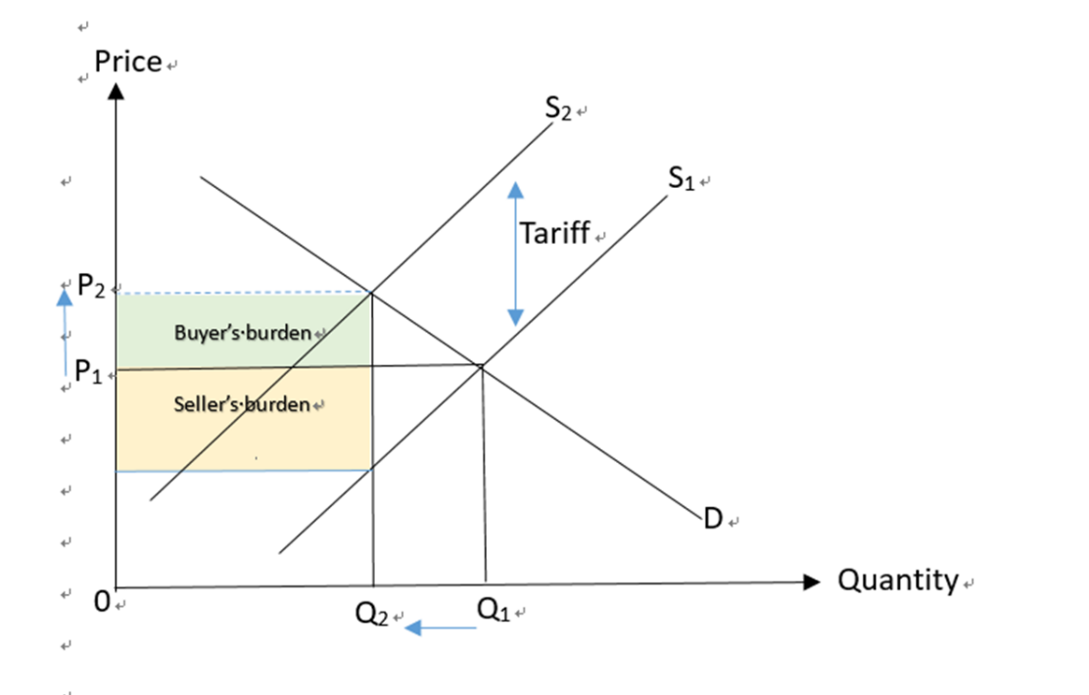
For part (e), students are required to present their answers in an essay form. Criteria for marking will include the use of sources and economic theories, relevant content, logical presentation and clarity of expression.

e) With references to the above sources, and your own knowledge in Economics, discuss the impacts of trade war on the following stakeholders:
- US importers
- US consumers
- US’ trading partners other than China
- One other group of stakeholders (12 marks)
Ans: First of all, the effect on US importers is uncertain. The imposition of tariff on China’s import will increase their cost of doing business, but they can shift the tax burden partly or wholly to their customers. Also, the depreciation of RMB makes import from China cheaper, and they can discover cheaper sources of imports from other places.

For the US consumers, they need to pay higher prices for Chinese-made goods. But there may be more substitutes from other places of the world for choosing.

For other trading partners of the US, they will gain as some US importers may import from them rather than from China. Also, some US manufacturers may move their production plants to there so more job opportunities can be created to the people there and those places can more income.

For other stakeholders e.g. the US workers, they may lose their job due to lower demand for their goods with tariff imposed by the Chinese government. Also, they need to suffer a higher cost of living in the US.

Another example is the US government who can gain more tariff revenue but the profits tax and salaries tax revenue may drop due to the shrinking of the businesses in the US. The overall effect therefore is uncertain. Moreover, the higher cost of living and higher unemployment may affect the social stability that may lead to discontent to the government.

